ORDER FORM
Order No. |  | Base type | Base size | Base color | Order status
 |  |  | W____ X L ____ |  | Regular order □
Oty.of.Pcs |  |  | Template □ |  | Rush order □

Hair  Style | Left Crown | Right Crown | Center Crown |  | Left  Part |  | Right Part |  | Center Part |  | Pompadour |  | Freestyle |  | others
Hair  Style | 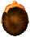 | 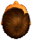 | 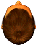 |  | 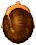 |  | 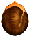 |  | 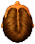 |  | 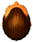 |  | 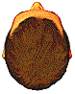
 |  |  |  | Front |  | Top |  | Crown |  | Temples |  | Sides |  | Back
Hair Texture 2mm-40mm
(weaves and curls)
Hair Density (60%-150%)
Hair Length

Hair Type |  | Main fiber | 1.Indian Remy__% 2.Chinese Remy__% 3. Synthetic hair__%
 |  | Grey hair | 1.Synthetic___ 2. Yak___ 3. Human___
Hair color |  | Front% | Top% | Crown% | Temples% | Sides% | Back%
Total % of Grey □
Extra% of Grey □
High light color □
Base  Hair color | Hair sample
Base  Hair color | Color ring

Undervent | □Front only. □All around | Undervent Density |  | 1.□Light 2.□Medium 3.□Heavy
Baby hair | □Yes □No
Special Instructions |  |  | 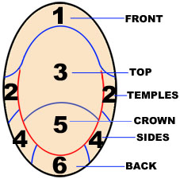 |  | Scalloped Front #__
1.□ Imprint Name & Date  2.□ Enclose Extra Hair |  |  |  |  | 