ORDER FORM
Company  Design for |  | Address
Company  Design for |  | Date |  | Order quantity

Hair type |  | Hair length |  | Hair color
Hair density |  | Hair texture |  | Hair style
Baby hair |  | Knots type |  | Bleach knot

Cap Design
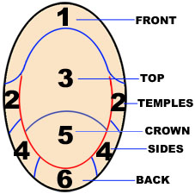 | Cap Design  [ ] Full Lace Wig  ( ) With stretch from ear to ear  ( ) With stretch in the middle  ( ) Lace (front) + Stretch net (back)  ( ) Lace in the Front + Machine made (back)
  Lace Color
  Lace Type
  Special requirements

Cap Size
Customized | Circumference | Front to Nape | Ear to ear across forehead | Ear to ear over top | Temple to temple round back | Nape of Neck
 | 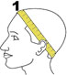 | 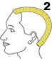 | 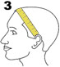 | 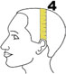 | 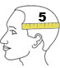 | 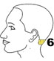
Size

